Prerequisites:

* Azure Devops
* Version Control(Azure Git)
* Image(Artifact)
* Azure Cloud(Deployment app)
* DataDog(Monitoring)
* SonarCloud(Code analysis)

Azure Devops:

Azure DevOps provides an integrated set of services and tools to manage your software projects, from planning and development through testing and deployment. Azure DevOps delivers services through a client/server model. Some services, such as source control, build pipelines, and work tracking, can also be managed through a client. It mainly has these services like Boards, Repos, Pipelines, Test Plans, Artifacts. All these processes can be managed using Agile Model

Boards:

Azure Boards is a web-based service that enables teams to plan, track, and discuss work across the entire development process, while it supports agile methodologies, including Scrum and Kanban. Azure Boards provides a customizable platform for managing work items, allowing teams to collaborate effectively and streamline their workflow. Through these work items in boards work from team members can be tracked effectively.

Repos:

Azure Repos is a set of version control tools that you can use to manage your code. Whether your software project is large or small, using version control as soon as possible is a good idea. Version control systems are software that help you track changes you make in your code over time. You can also import Git repo and use them for build purposes.

Pipelines:

CI(Continuous Integration): Continuous Integration (CI) is the practice used by development teams of automating, merging, and testing code. CI helps to catch bugs early in the development cycle, which makes them less expensive to fix. Automated tests execute as part of the CI process to ensure quality.

CD(Continuous Delievery): Continuous Delivery (CD) is a process by which code is built, tested, and deployed to one or more test and production environments. Deploying and testing in multiple environments increases quality. CD systems produce deployable artifacts, including infrastructure and apps.

Test Plans:

Azure Test Plans provides rich and powerful tools everyone in the team can use to drive quality and collaboration throughout the development process. The easy-to-use, browser-based test management solution provides all the capabilities required for planned manual testing, user acceptance testing, exploratory testing, and gathering feedback from stakeholders.

Artifacts:

Azure Artifacts enables developers to share their code efficiently and manage all their packages from one place. With Azure Artifacts, developers can publish packages to their feeds and share it within the same team, across organizations, and even publicly. Developers can also consume packages from different feeds and public registries such as NuGet.org or npmjs.com.

SonarCloud:

SonarCloud is a cloud-based code quality and security service. The main features of SonarCloud are:

* 23 languages: Java, JS, C#, C/C++, Objective-C, TypeScript, Python, ABAP, PLSQL, T-SQL and more.
* Thousands of rules to track down hard-to-find bugs and quality issues thanks to powerful static code analyzers.

Datadog:

Datadog is a monitoring and analytics tool for information technology (IT) and DevOps teams that can be used to determine performance metrics as well as event monitoring for infrastructure and cloud services. The software can monitor services such as servers, databases and tools.

Steps:

* Create an organization in azure Devops and create project in that organization.
* Now, Create a user story through boards in Project for assigning work to the members in project. It is same like JIRA tool in Tracking work Progress
* Now, Assign tasks for different members in same project.
* Now, Import Repo the Azure Git Repo in the Project dashboard.
* We can use it for maintaining the code using Different branching mechanism for different members.
* Create Sonarcloud Organization and integrate with azure Devops through PAT(personal access token) which can be obtained in profile in Azure Devops.
* 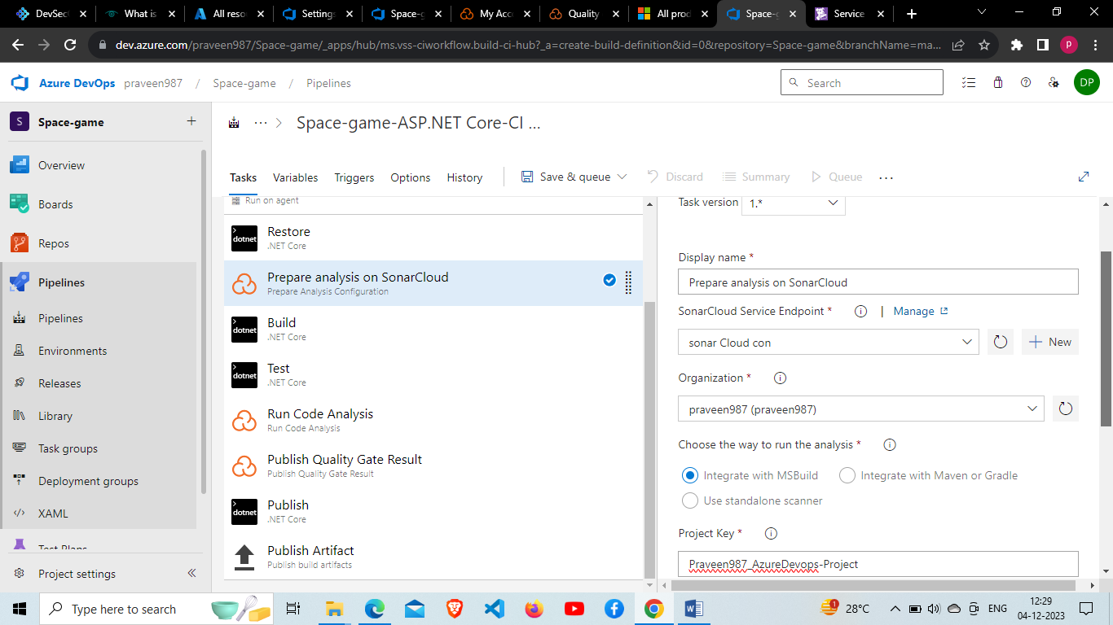
* Now, Create a SonarCloud account and Create a Project in sonarcloud same name as Project in Organization.
* 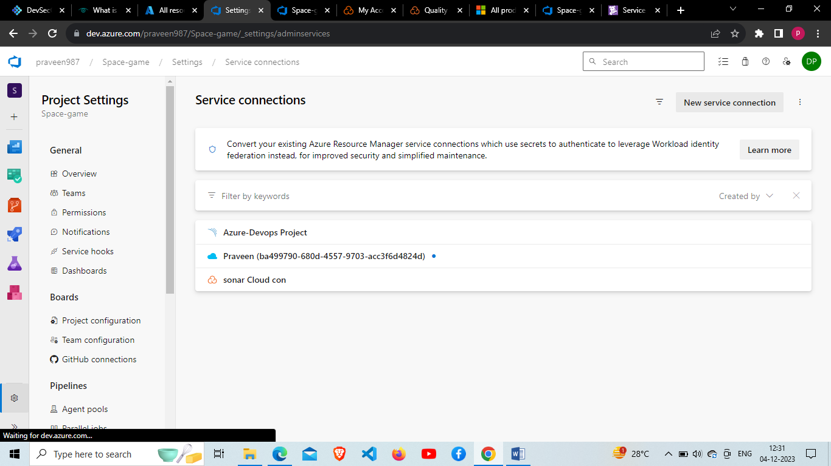
* Now create a service Connection In Project settings for Sonarcloud Connection and go to sonarCloud and Generate Token In Security under profile section of Sonar Cloud.
* Create datadog Account for monitoring the entire process for building and release purposes and also download azure Devops and configure it.
* Create Service hooks in Project setting use the Api Key generated from Data dog for creating Datadog monitoring Hooks.
* 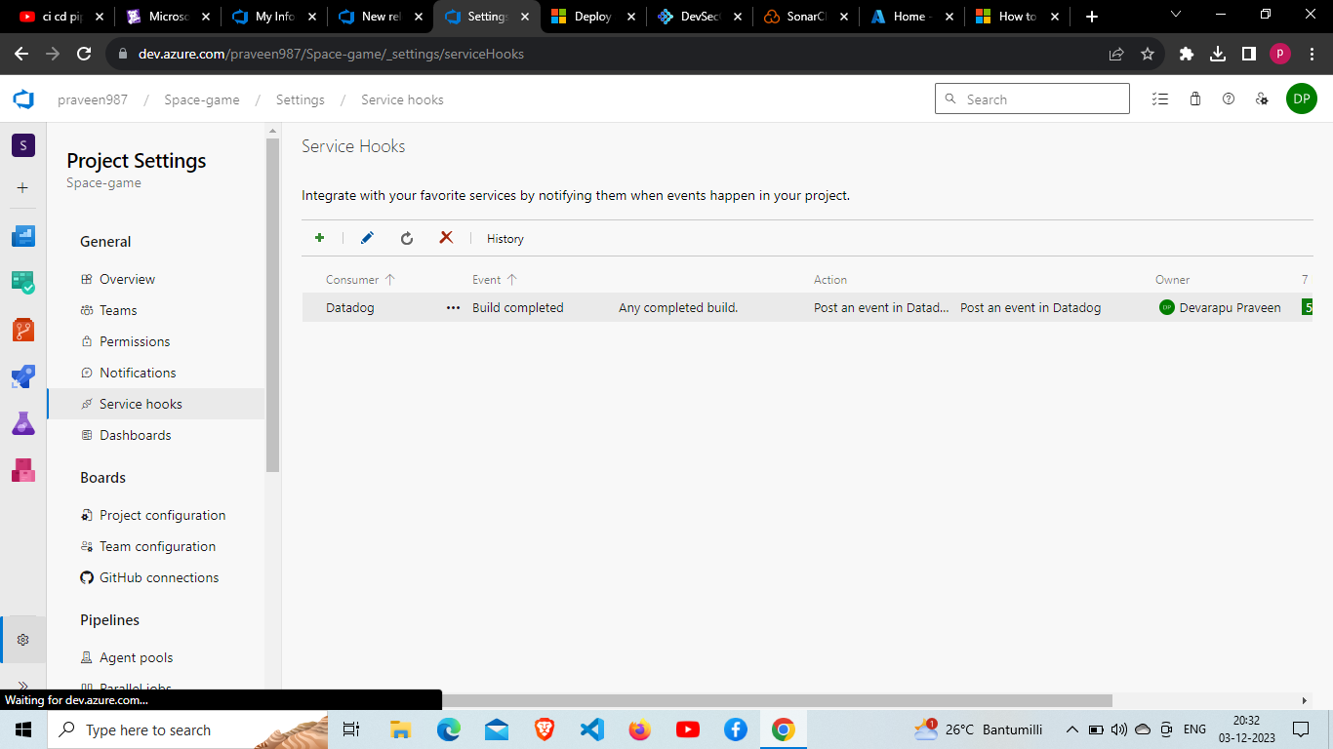
* Now, integrate it with PAT same as In SonarCloud process.
* Integration of code analysis and monitoring is completed now Create the CI pipeline(build)
* 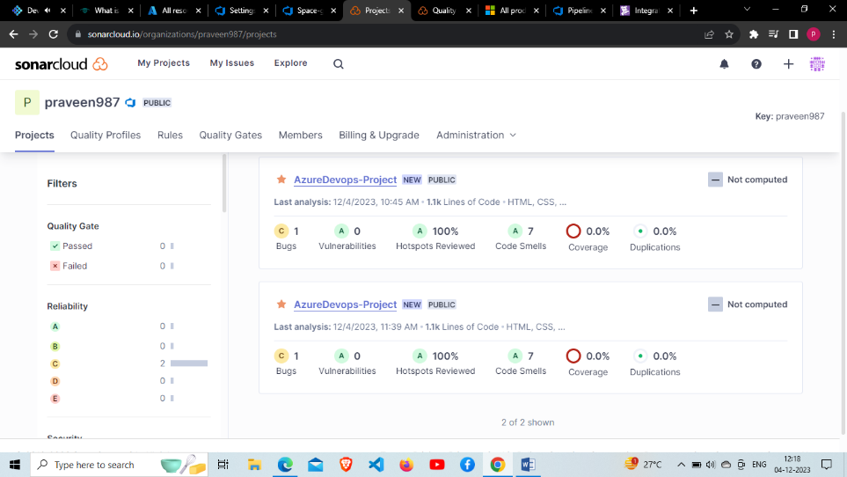
* Create Service connection for Azure Resource manager in project settings and configure subscription and Resource group.
* 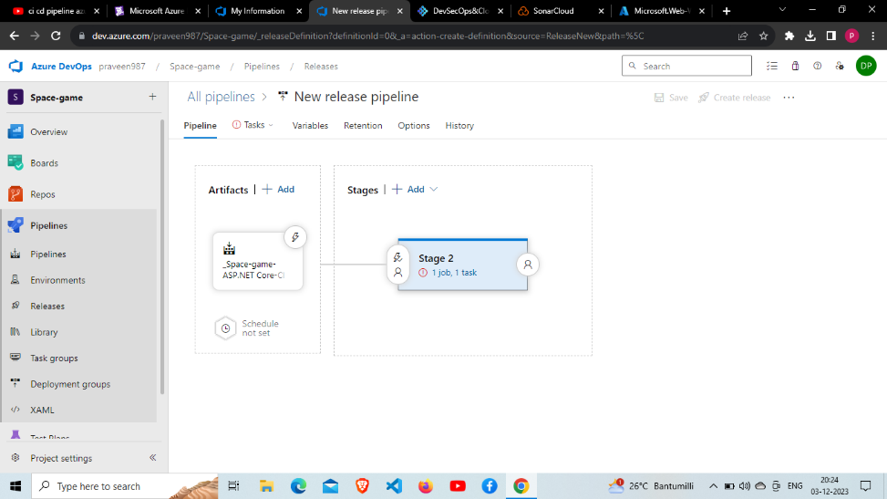
* Add Release pipeline For Build pipeline created. We can observe Artifact generated by the build through which we can use it in release stage
* 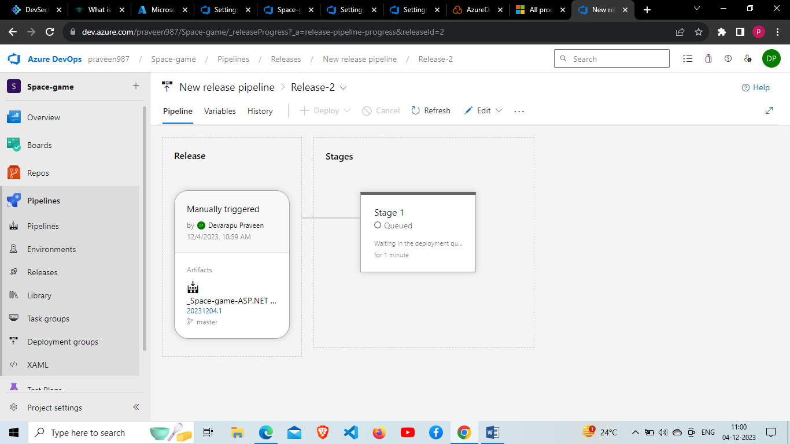
* Now, Configure artefact to release and add app deployment service in agents(web app) in azure which can used through azure resource manager.
* Configure app deployment service and Stage it to the job and save it
* Start the release pipeline wait for it to deploy the artifact to web app
* Now, we can check the application through which web app has been deployed.
* 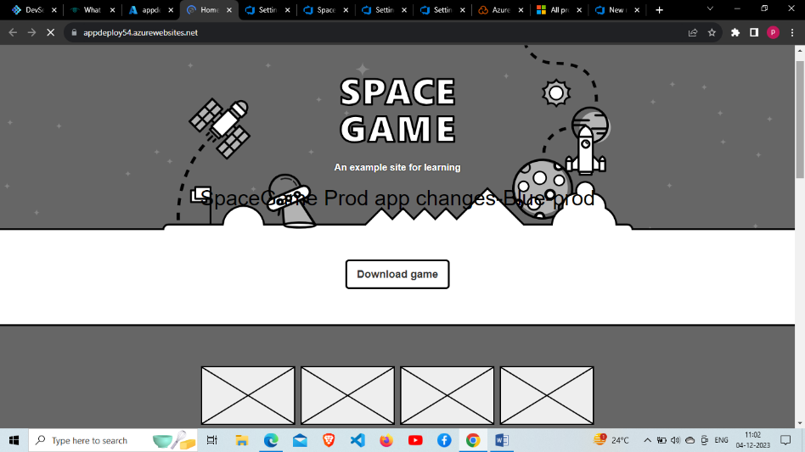
* We can also observe datadog monitoring through integration in datadog dashboard.
* Task is completed we should update in the user story